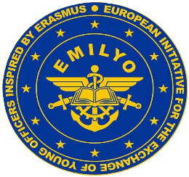

COMMON MODULE: AVIATION ENGLISH PART 1
16th - 27th September 2024

Please fill-in the Registration Form using CAPITAL LETTERS and inserting “X”
where required.

Male | Female | Rank | Status (Cadet/Officer) | Family name (surname) | First name

Date of birth | Nationality | Passport/ID number | Passport/ID  validity until

Branch of Service (if available) | Sending Institution

Mobile phone number  (including country code) |  | e-mail address
Arrival  to Dęblin | Means of transport  (e.g. train, bus, car) |  | Arrival date | Arrival time to Dęblin  (if available)
Departure from Dęblin | Means of transport  (e.g. train, bus, car) |  | Departure date | Departure time from Dęblin  (if available)

Special dietary or food requirements due to medical  or religious reasons |  | If yes, please specify
No | Yes

Additional remarks (needs for special equipment, special travel arrangements, etc.)

Point of contact (POC) of the Sending Institution
Male | Female | Rank | Family name |  | First name
POC phone number (including country code) |  |  |  | POC e-mail address
Deadline for submitting the Registration Form: 14th July 2024

Please send the Registration Form directly to our POC:
Mrs Karolina Kozak, email: k.kozak@law.mil.pl, phone: +48 261 517 190

Please integrate a photo of your passport / ID hereinafter:

